Test Case 1:

Try to alter records outside application

Step 1: update record (not using application)

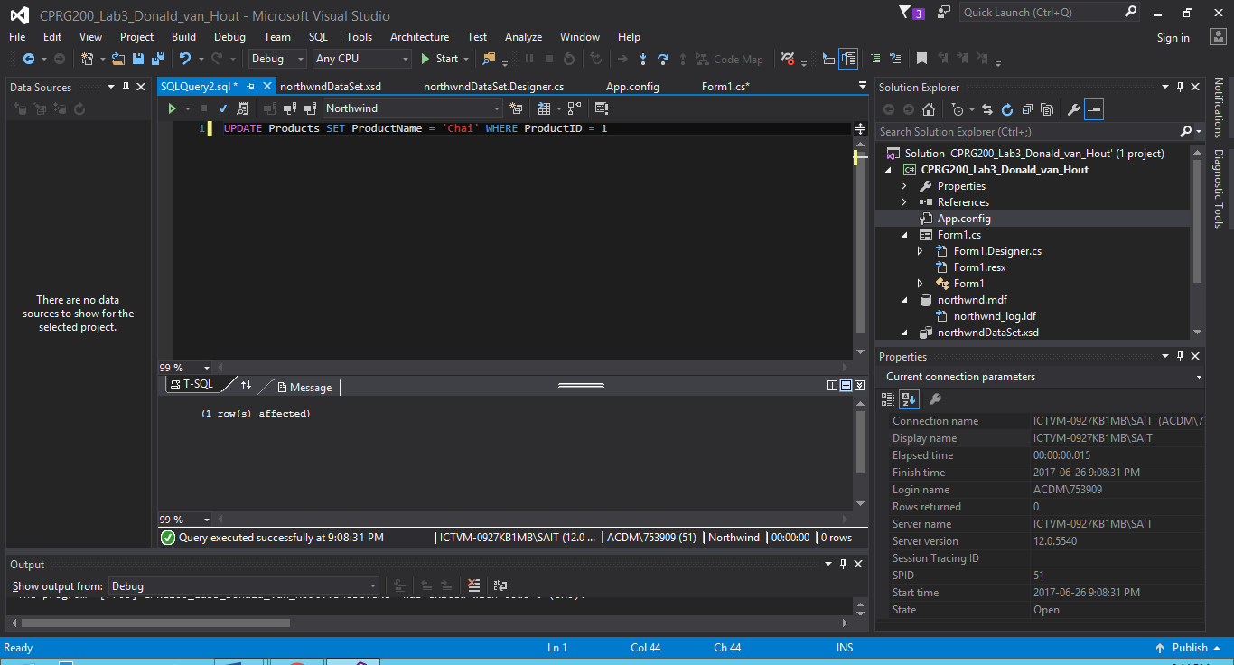

Step 2: try to update data from within application

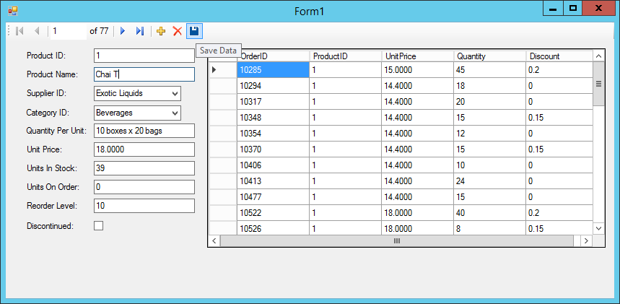

Step 3: (successful catch)

catch (DBConcurrencyException):

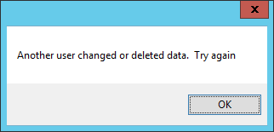

Test Case 2: Try to delete a record where Foreign Key relationship exists

Step 1: delete a record from within application

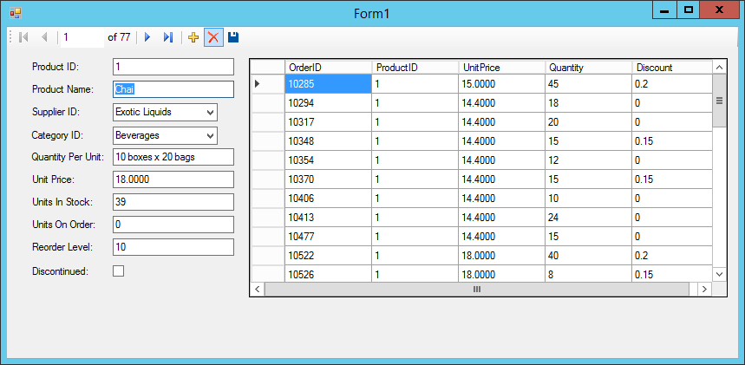

Step 2: (successful catch)

catch (SqlException ex):

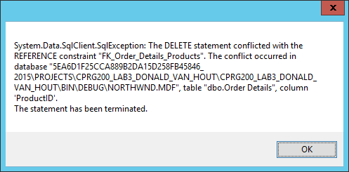

Test Case 3: Try to alter records with wrong types in fields

Result: does not allow entry, will not save record

Test Case 4: Try to create a new record with wrong types in fields

Result: does not allow data entry, will not create record, will not save, will not exit

Test Case 5: Try to change id of record

Result: does not allow change, will not alter, will not save or allow close

Test Case 6: Try to alter Order Details (read only) form

Result: cannot alter, no access

Test Case 7: Enter data with ‘Null’ values

Result: NoNullAllowedException caught on ‘ProductName’, ‘SupplierID’, ‘CategoryID’, and ‘Discontinued’ fields. Okay for other fields

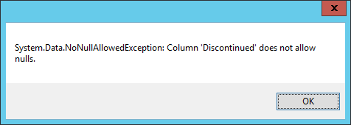

Test Case 8: Try to create record with negative ProductID

Result: Will not allow, ProductID is automatically generated regardless of value entered